Presenters/ Instructors
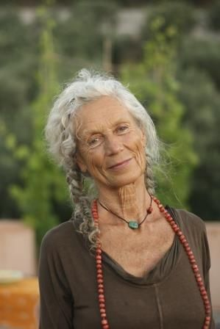
Angela Farmer: "I believe it is time to listen inside again—to feel, to question, to explore, and trust our inner voices, rather than jump into alignment on command.” Angela Farmer was one of the earliest students of B.K.S. Iyengar and studied with him for a decade in Pune India and also London. Three of Angela’s trips to India in particular were comprehensive and it was during that time she met and practiced with extraordinary saints and yogis. Her life dramatically changed at a temple in Orissa, where she was awakened to the feminine approach to Yoga. Her life’s work for more than 40 years has brought her worldwide respect and accolades. Her reach across the globe has inspired women in yoga for generations to come and awakened men also. One woman that came from India to train with Angela was asked “how did you find out about Angela” and she said “the guru at the Ashram in India whispered in my ear one day “if you want to find real yoga, find Angela Farmer”.

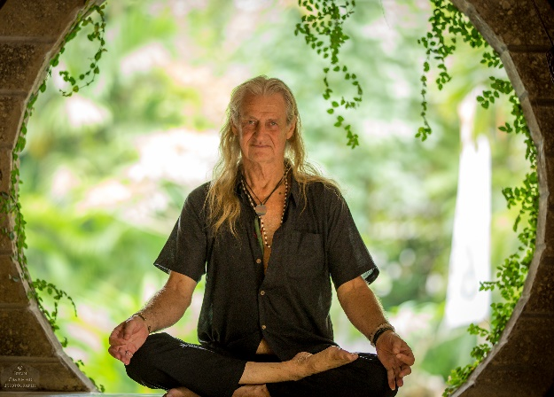
Mark Whitwell: “Yoga is your direct intimacy with the nurturing power of Life. It is the practical means adapted to personal needs, age, health and all cultures.” Mark Whitwell is interested in developing an authentic yoga practice for the individual, based on the teachings of Tirumalai Krishnamacharya, "the teacher of the teachers," and his son T.K.V. Desikachar. After first meeting these two great teachers in 1973, Mark realized the importance of their scholarship and committed his life to furthering the communication. His teachings clarify the profound relevance of ancient wisdom to modern times. Mark has taught yoga for many years throughout the world, adapting the principles of the Great Tradition to the needs of people from many cultures and many countries. He was the editor of and contributor to T.K.V. Desikachar’s book, The Heart of Yoga: Developing a Personal Practice, and is the author of Yoga of Heart and The Promise.

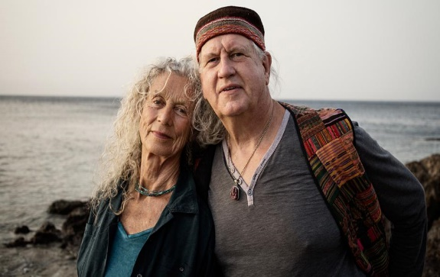
Victor Van Kooten : “The body rests over the breath and is moved by the inhalation and exhalation. Like a plant waving inside the forever rocking ocean of life” Victor is a Dutch born Yoga teacher and artist who studied with B.K.S. Iyengar in the late sixties and seventies as one of the earliest students. At one time he was considered Iyengars prize student. Since 1984, Victor has been teaching with Angela Farmer. His books, From the Inside Out I, II, III and IV are illustrated yoga notebooks based on the teachings he and Angela have developed.

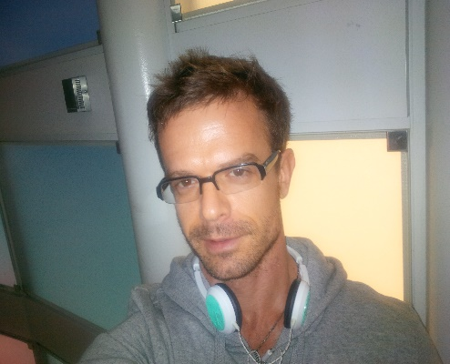
Mark Allen Devenpeck "the library of our lives becomes the ultimate reference and resource to come back to and revisit, helping us to discover the foundation our very existence". Initially a contemporary and ballet dancer, the yoga seed was planted by a dance partner in college that spoke of the wonderful class located at the campus chapel. As co-founder, with Newton Campbell, of Triad Yoga & Pilates in Newport Beach/ Irvine CA, Mark has had the profound privilege of his studio celebrating 16 years of service this September. Mark has trained with Manju Jois at the Omega Institute, spent time at Mount Madonna with Baba Hari Dass. Kripalu, and studied at Kripalu and the New York Open Center. He appreciates the wealth of knowledge and guidance he has received from Cyndi lee from Om Yoga, Mark Whitwell and the beloved Angela Farmer. His training's at Duke Medical have lead him to his quarterly lectures and instructions at USC KECK School of Integrative Medicine. His new True Colors Yoga at Peace Yoga Gallery in Downtown LA is also an extension of all his life's work. Mark’s mindfulness based approach to discovering the inner landscape of the body is what helped him recover and heal from an unexpected Kundalini Rising that almost lead to his death, a brain injury 7 years ago. This incident has been the single most important guiding light in the classes he teaches today.

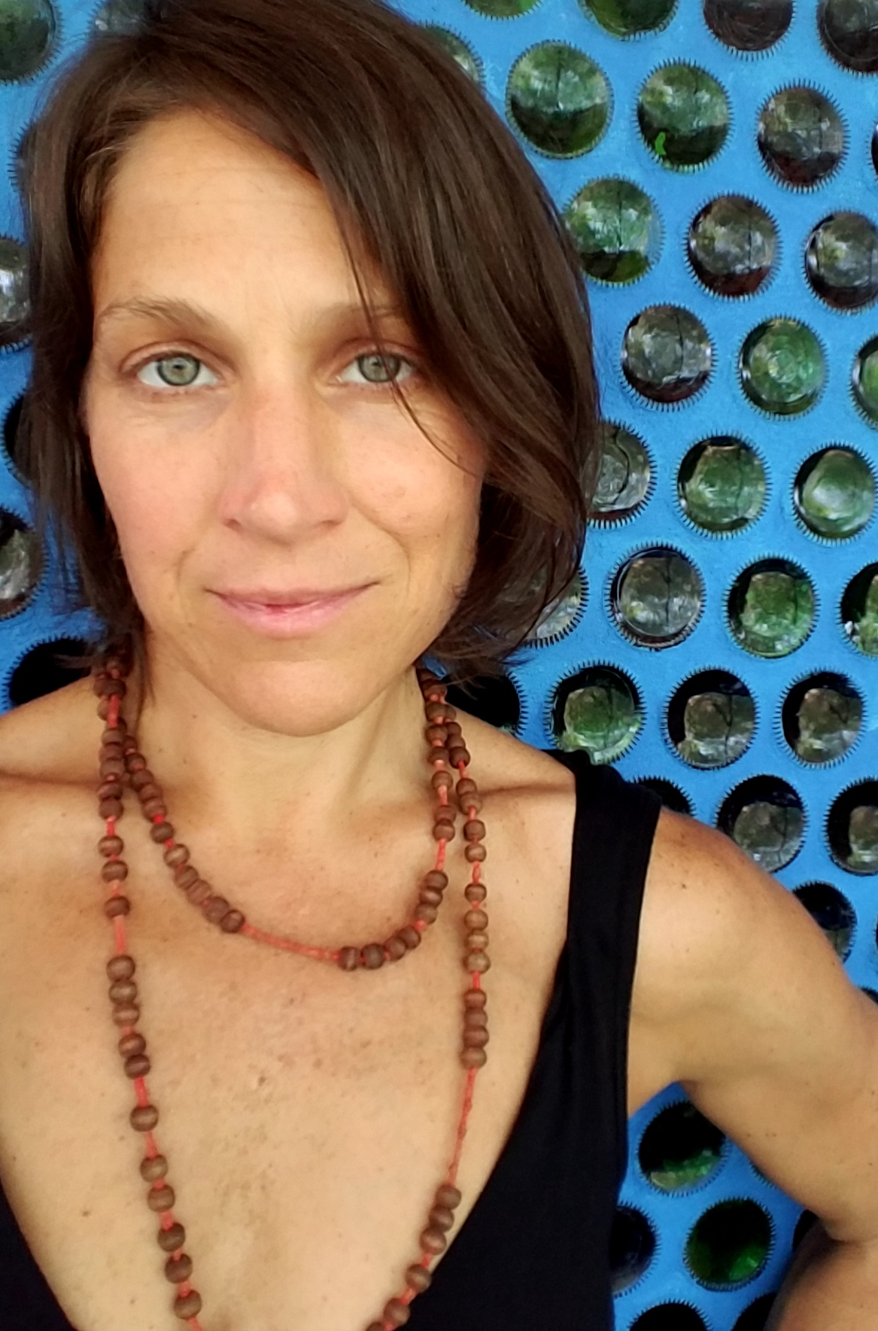
in 1987
yoga changed my life
31 years of this
self love practice
gives me the strength to serve

YOGA is
continuous transformation.

come experience BLISS beyond words
with the TRUTH tellers
in this MAGICAL gathering
of the masters
as we return to GRACE cheri rae

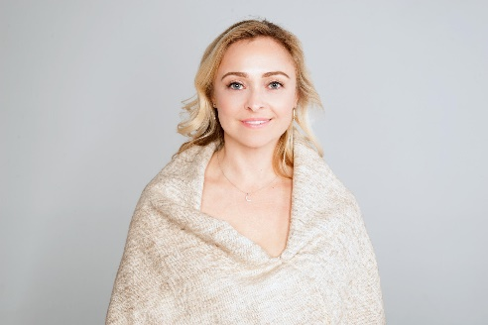
Terra Gold "When we combine gratitude with our ability to sense, touch, and feel, the blessings that arise are a gateway. We are awakened to the wisdom within us. We re-member wholeness, and yoga lives through us.” Having taught yoga for 20+ years, Terra Gold is a certified yoga therapist, licensed acupuncturist and Chinese Medicine practitioner, a clinical nutritionist and has an allied professional degree in integrative body psychotherapy. She is trained in dance movement therapy and vocal/sound therapy. She weaves vocal yoga practices into the asana classes she guides, as well as sharing chanting and kirtan. Terra is the Director of the “Yoga and the Healing Sciences” Teacher Training Program at Loyola Marymount University, and co-wrote the textbook Yoga Therapy and Integrative Medicine: Where Ancient Science Meets Modern Medicine. Terra’s therapeutic flow classes challenge people with different levels of ability, while being suitable for all levels. Each class is a blend of ancient tradition with modern therapeutic variations that inspire people to find their own inner alignment through the balancing principles that create stability and ease in one’s own body and one’s life. Terra fuses the esoteric with the scientific, yin with the yang and each class is designed to inspire you to maintain a conscious heart, an intelligent mind while you challenge your inner sense of balance, and an embodied presence of spirit no matter what life brings your way.

